Lab 6:
Name: Laiba Asim
Sap id: 65230

Task 1:

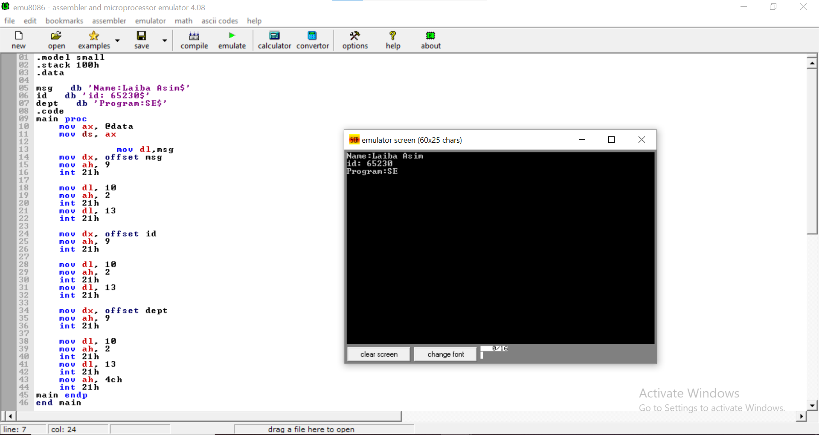

Task 2:
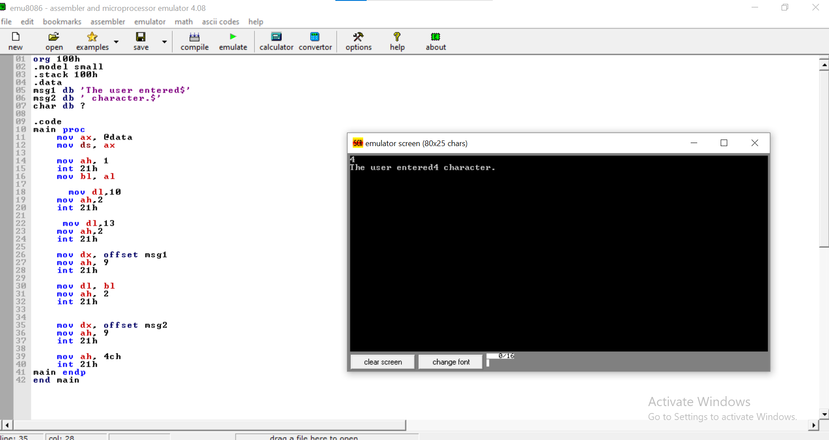

Task 3:
